**Assignment 2b - KUBERNETES**

Name: Naren Chandrashekhar

SRN: PES2UG20CS216

Section: D

1. Section 1: Installation
   * Screenshot 1a - Minikube running successfully

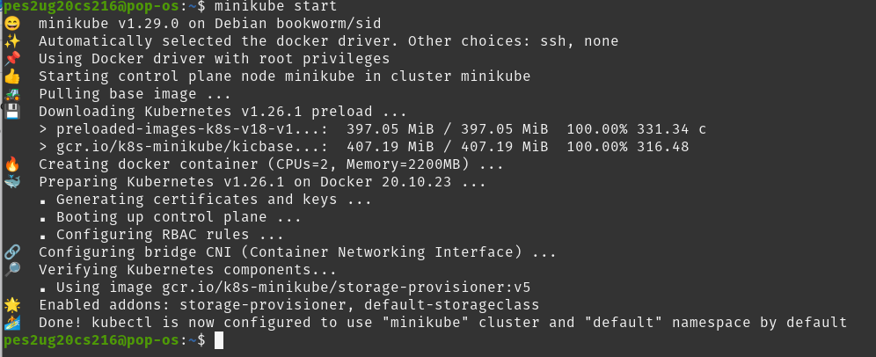

1. Section 2: Creating pods and deployments, Editing them and observing Rollback:-

* Screenshot 2a - get nodes, pod and services command.

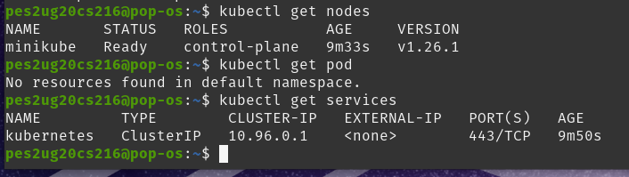

* Screenshot 2b- Deployment created.



* Screenshot 2c- get deployment and pod command .

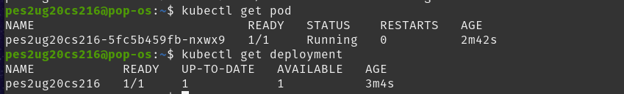

* Screenshot 2d- editing ‘-image:nginx.’



* Screenshot 2e- showing edited deployment.



* Screenshot 2f- deployment is rolled back.



* Screenshot 2g- showing original nginx image.

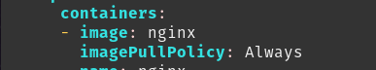

1. Section 3:Debugging Pods:-

* Screenshot 3a - Kubectl logs displayed.

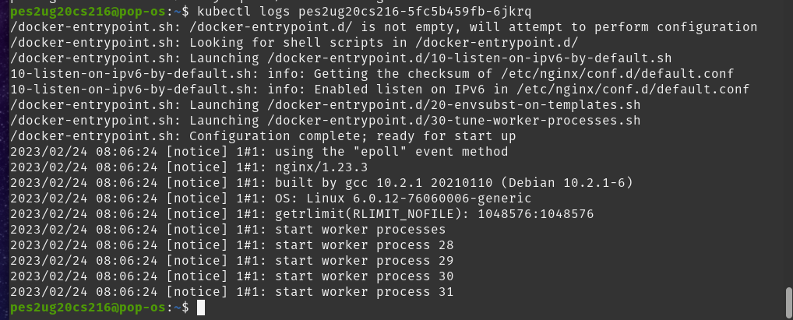

* Screenshot 3b- Kubectl ‘describe pod ‘ command.

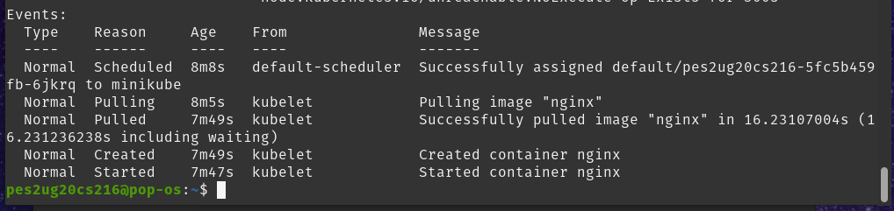

* Screenshot 3c - Create mongo deployment.

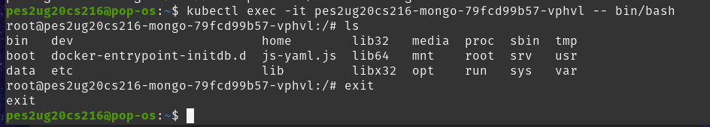

* Screenshot 3d - Delete both requirements.

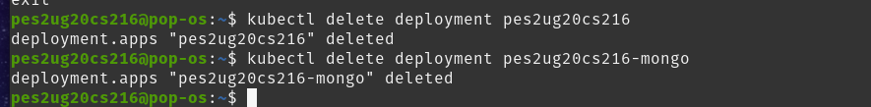

1. Section 4: Applying configuration files:-

* Screenshot 4a - Kubectl apply command on yaml file.



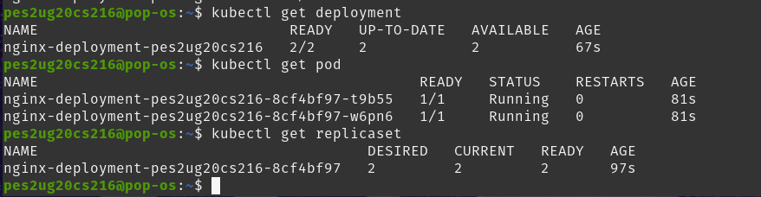

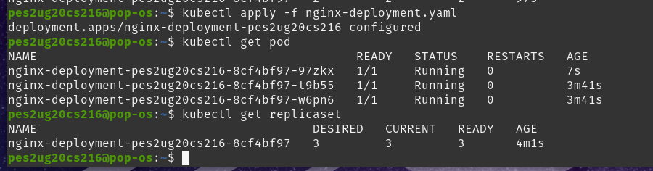

* Screenshot 4b- Kubectl get on yaml file

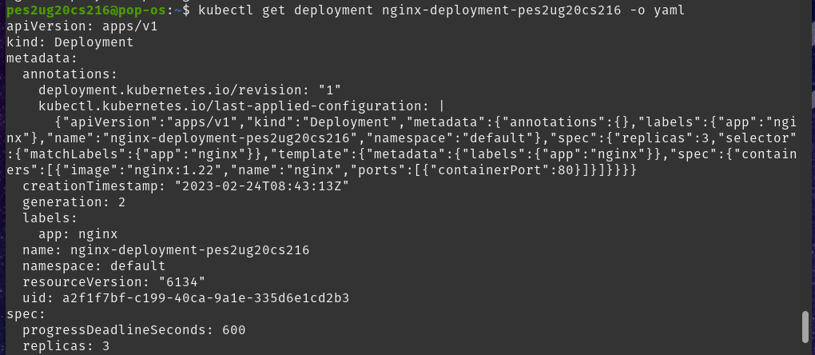

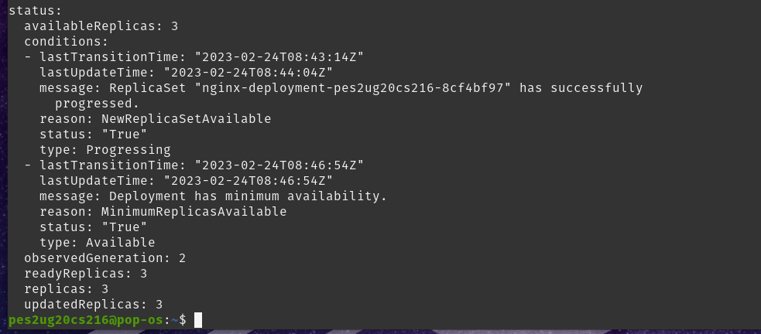

1. Section 5: Delete a pod to observe the self-healing feature.

* Screenshot 5a - Deleted pod:-

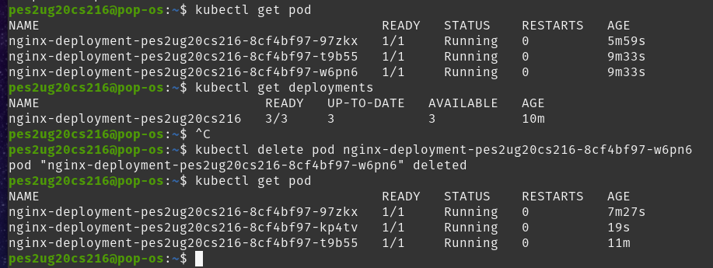

1. Section 6 : Connecting Services to Deployments

* Screenshot 6a- Kubectl apply and get command.

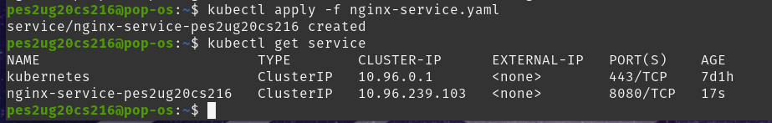

* Screenshot 6b-kubectl get pod -o wide command

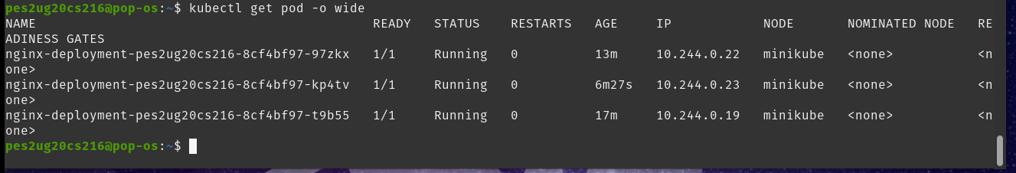

1. Section 7: Port Forwarding:-

* Screenshot 7a -Kubectl port-forward command

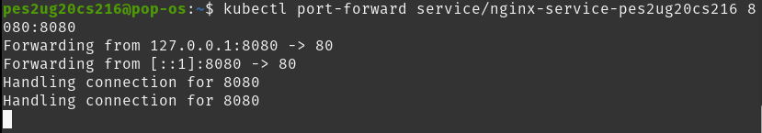

* Screenshot 7b- Display welcome to nginx on web page

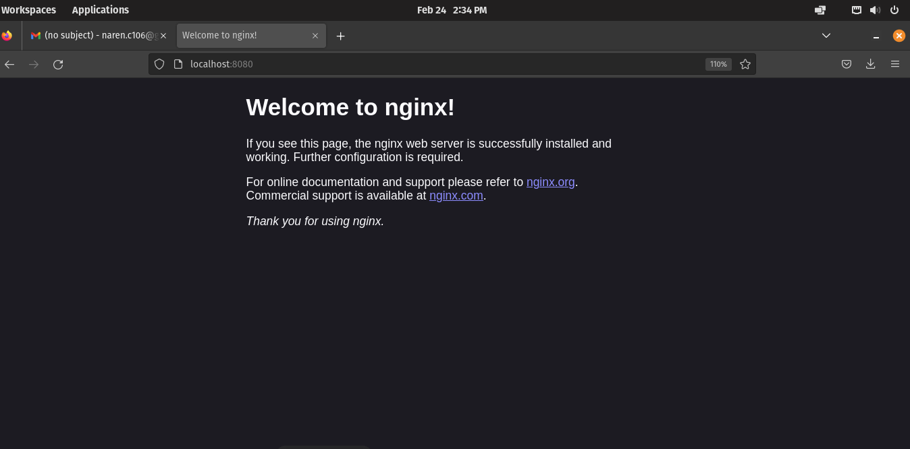

1. Section 8: Deleting service/deployment and Cleanup

* Screenshot 8a - Delete nginx deployments





* Screenshot 8b - stop minikube

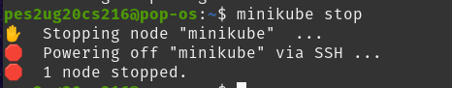

1. Section 9:Expose an external IP address to access an Application in a cluster

* Screenshot 9a- the command which exposes specifies the type of service (NodePort)

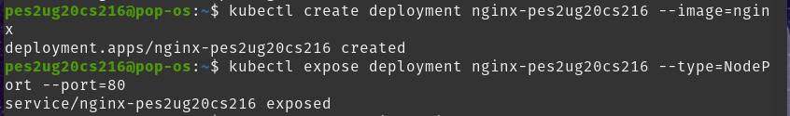

* Screenshot 9b - kubectl get service command which displays the node port



* Screenshot 9c - minikube IP address



* Screenshot 9d - the webpage with the IP Address visible. (If the IP Address is not visible in the screenshot, you will lose significant portion of marks w.r.t. Section 9)

